Error handling

Syntax errors - programmer mistake

Runtime errors == Exceptions need to write handling code – due to user input, programmer logic or memory

Why we need to handle errors

* To avoid program termination abnormally

Try:

Risky code

Except:

Handling code

Finally:

Mandatory code

Raise:

Handling custom error

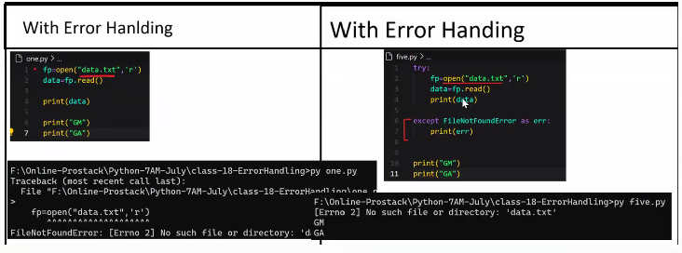

Errors and exceptions in java vs python

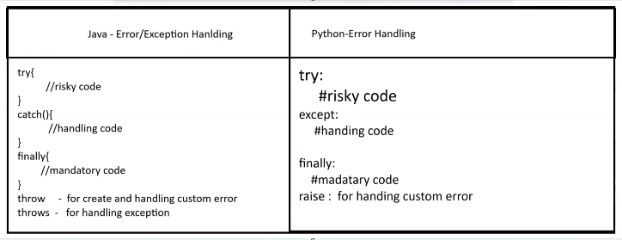

Errors:

